*UNLOCKING INSIGHTS INTO THE GLOBAL AIR TRANSPORTAION NETWORK*

INTRODUCTION**:**

Global air transportation plays a crucial role in connecting people and businesses across the world. It offers numerous advantages, such as speed, global connectivity, accessibility, safety, and reduced traffic congestion. However, it also has its disadvantages, including cost, environmental impact, limited cargo capacity, weather dependence, and security concerns. Despite these drawbacks, air transportation continues to be a vital mode of travel and trade, enabling individuals and goods to reach their destinations quickly and efficiently.To extract the insights from the data and put the data in the form of visualization,dashboards and story we employed tableau tool.

1.1 OVERVIEW:

Globalair transportation plays a crucial role in connecting people and businesses across the world. It offers numerous advantages, such as speed, global connectivity, accessibility, safety, and reduced traffic congestion. However, it also has its drawbacks, including high costs, environmental impact, limited cargo capacity, weather dependence, and security concerns**.**

1.2 PURPOSE:

The purpose of air transportation is to provide a fast, efficient, and safe means of transporting people, goods, and services over long distances. It allows for quick travel between cities, countries, and continents, enabling business and tourism to flourish. Overall, air transportation helps connect people and economies, fostering economic growth, cultural exchange, and global connectivity.

**2.problem statement**&***design thinking***:

Problems of global air transportation:

One of the main problems with global air transportation is the high costs associated with it. Air travel is generally more expensive compared to other modes of transportation such as road or rail. This cost can be a barrier for many people, especially those with lower incomes, limiting their ability to travel by air.

Another significant problem is the environmental impact of air transportation. Aircraft emit greenhouse gases and contribute to climate change. Additionally, airports and aircraft noise can have negative effects on local communities, leading to concerns about air pollution and noise pollution.

Overall, while global air transportation offers numerous advantages, it also faces several challenges that need to be addressed. Efforts are being made to reduce its environmental impact through the use of more fuel-efficient aircraft and the development of sustainable aviation fuels. Additionally, advancements in technology and infrastructure are being made to improve efficiency and security in air travel.

2.1 EMPATHY MAP:

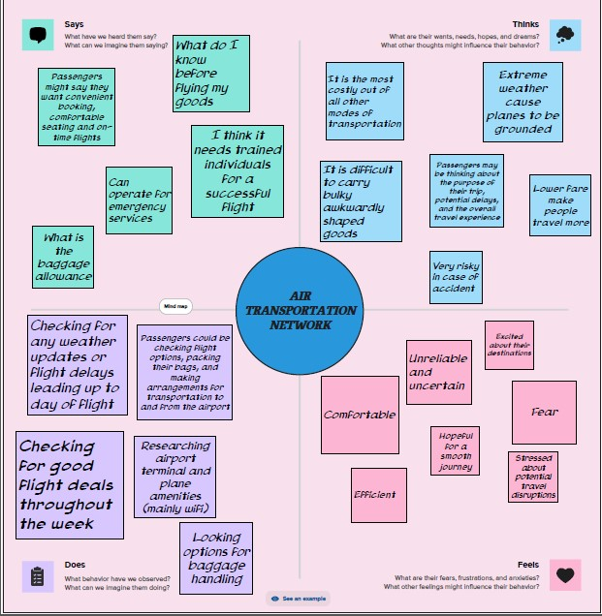

2.2 IDEATION AND BRAINSTORMING MAP:

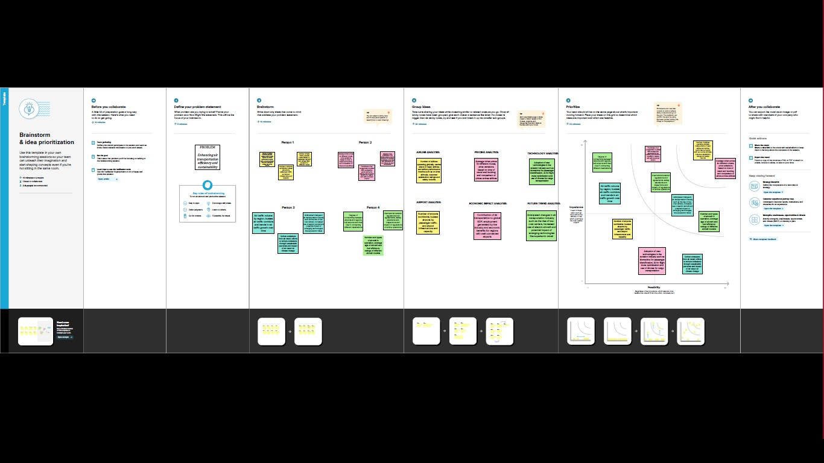

3.RESULT:



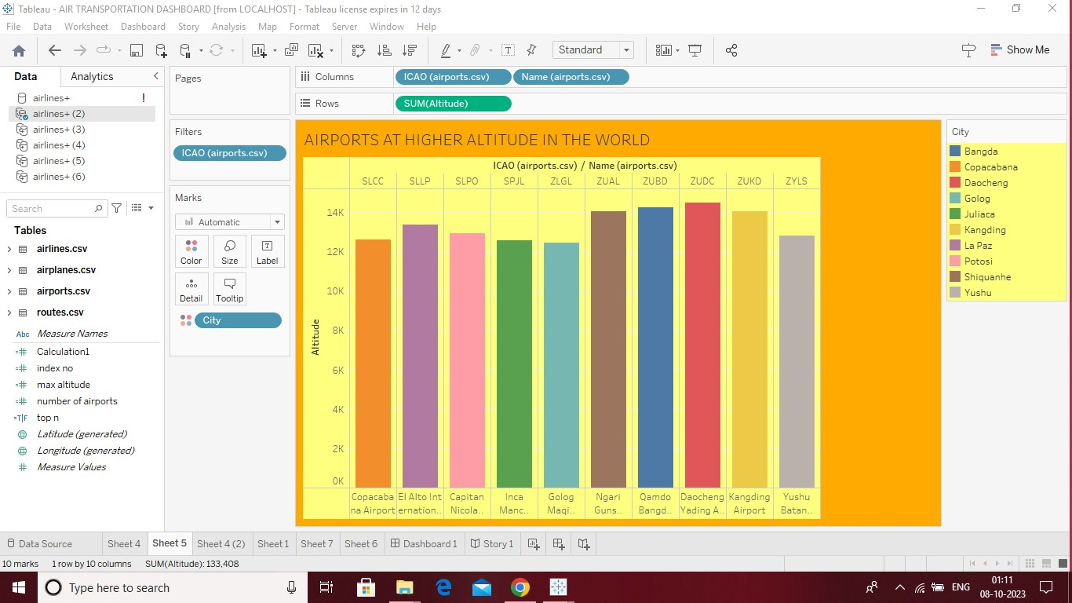

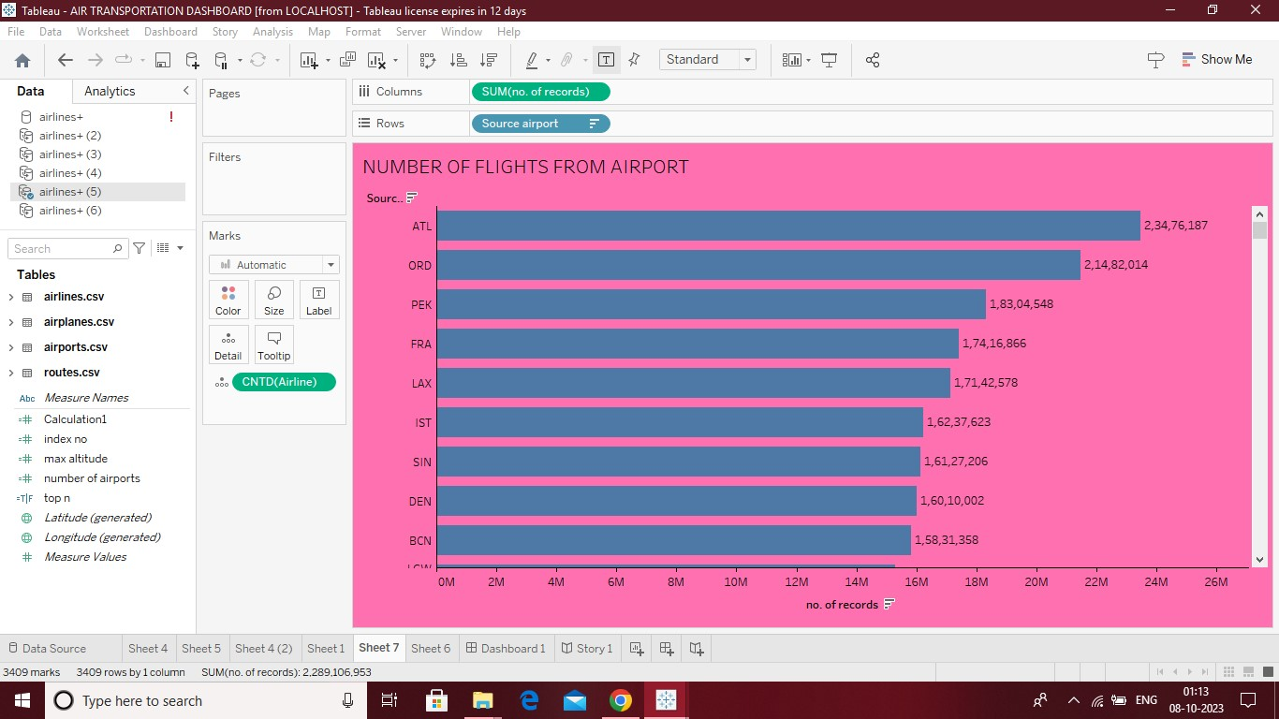

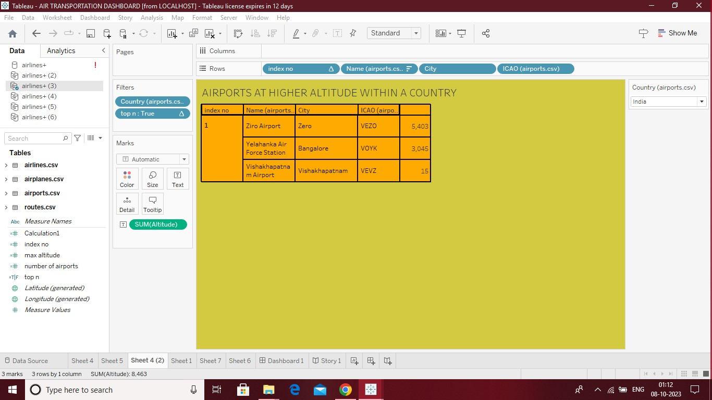



DASHBOARD:



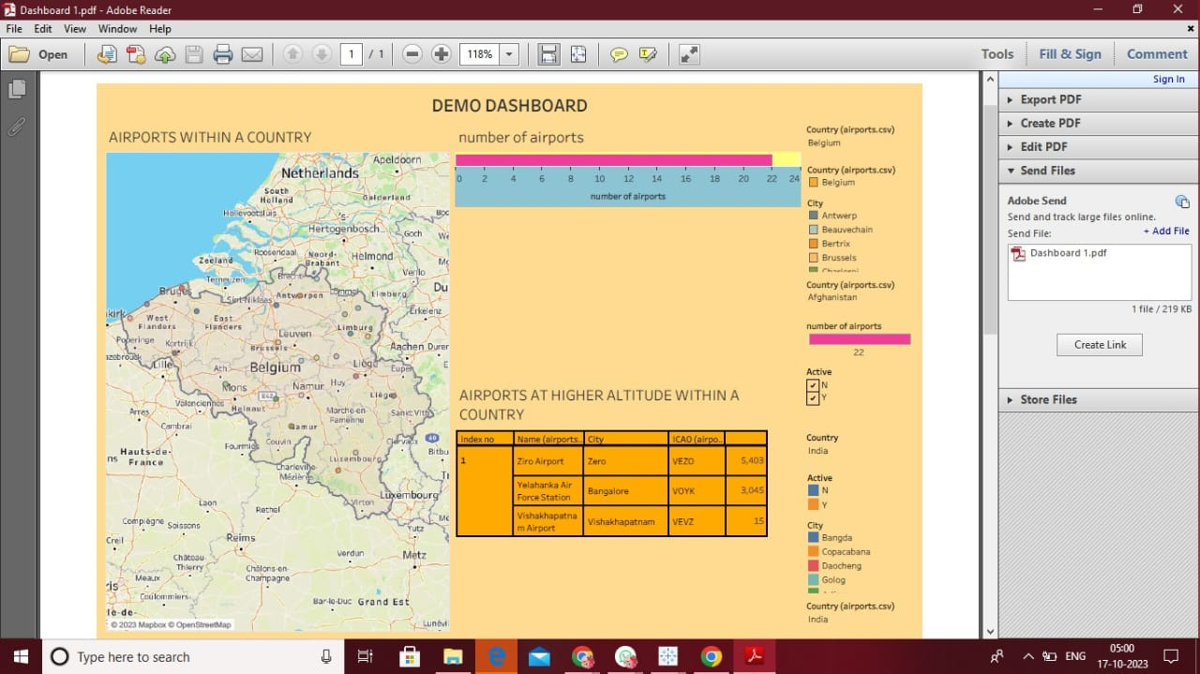



STORY:

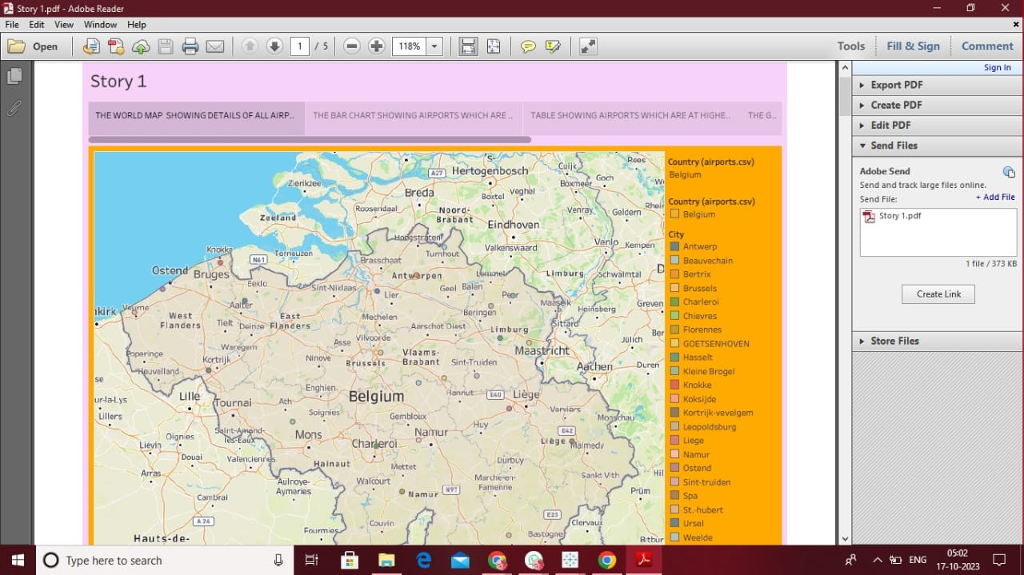

4.ADVANTAGE AND DISADVANTAGE:

ADVANTAGE:

1. Speed: Air transport is the fastest mode of transportation, allowing people and goods to reach their destinations quickly.

2. Global connectivity: Air transport connects people and businesses across the world, enabling international trade and tourism.

3. Accessibility: Airports are usually located near urban areas, making air travel easily accessible to a large population.

4. Safety: Air travel is considered one of the safest modes of transportation, with strict regulations and advanced technologies ensuring passenger safety.

5. Reduced traffic congestion: Air transport helps alleviate road congestion by reducing the number of vehicles on the road.

DISADVANTAGE:

1. Cost: Air travel can be expensive, especially for long distances, making it less accessible for some individuals and businesses.

2. Environmental impact: Airplanes contribute to greenhouse gas emissions and air pollution, which can have negative effects on the environment and human health.

3. Limited cargo capacity: Compared to other modes of transportation like ships or trains, airplanes have limited cargo space, making them less suitable for transporting large quantities of goods.

4. Weather dependence: Air travel is highly dependent on weather conditions, and adverse weather can cause delays or cancellations.

5. APPLICATION:

1. Passenger travel: Air travel allows people to reach their destinations quickly and efficiently, especially for long-distance or international trips. It is commonly used for business travel, tourism, and visiting friends and family in different countries.

2. Freight and logistics: Air transportation is essential for shipping time-sensitive and high-value goods. It is commonly used for transporting perishable items like fresh produce, pharmaceuticals, and flowers. Air cargo is also preferred for urgent deliveries or when distance is a limiting factor.

3. Emergency services: Air transportation plays a vital role in emergency response and disaster relief efforts. It enables the rapid deployment of medical teams, supplies, and equipment to affected areas. Air ambulances are also used for transporting patients who require immediate medical attention.

4. Remote areas and islands: Air travel provides a lifeline to remote areas and islands that are inaccessible by road or sea. It allows residents to access essential services like healthcare, education, and supplies. It also supports tourism in these regions, contributing to their economic development.

6. CONCLUSION:

In conclusion, global air transportation has its benefits in terms of speed and accessibility, but it also faces significant challenges. The high costs associated with air travel can limit its accessibility to certain individuals and communities. The environmental impact of aircraft emissions and the negative effects on local communities also need to be addressed. The limited cargo capacity and weather dependence further hinder the efficiency and reliability of air transportation. Lastly, security concerns pose a challenge in ensuring the safety of passengers. However, efforts are being made to address these challenges through advancements in technology, infrastructure, and sustainable practices. With continued innovation and improvements, global air transportation can become more efficient, environmentally friendly, and accessible for all.

7. FUTURE SCOPE:

1. Sustainable aviation: The industry is increasingly emphasizing sustainability and reducing its environmental impact. This includes the development and adoption of more fuel-efficient aircraft, the use of sustainable aviation fuels, and exploring alternative energy sources such as electric and hydrogen-powered planes.

2. Technological advancements: The use of advanced technology is expected to revolutionize air transportation. This includes the implementation of autonomous aircraft, improved air traffic management systems, and the integration of artificial intelligence to enhance safety, efficiency, and passenger experience.

3. Supersonic travel: Efforts are underway to bring back supersonic travel, which could significantly reduce travel times. Companies like Boom Supersonic and Aerion are working on developing supersonic jets that are quieter, more fuel-efficient, and capable of flying at speeds over Mach 1.

Overall, the future of air transportation holds immense potential for growth and innovation. As technology continues to advance and sustainability becomes a top priority, we can expect air travel to become more efficient, environmentally friendly, and accessible to a larger population.

**THANK YOU**